The Upside of Income Inequality

By Gary S. Becker and Kevin M. Murphy
From the May/June 2007 Issue

Much of the widening gap in incomes reflects the rising payoff for a college education and other skills. Rising payoffs are a development that the authors, economists who have won the Nobel Prize and the Clark Prize, call ‘beneficial and desirable.’

Income inequality in China substantially widened, particularly between households in the city and the countryside, after China began its rapid rate of economic development around 1980. The aver­age urban resident now makes 3.2 times as much as the average rural resident, and among city dwellers alone, the top 10 percent makes 9.2 times as much as the bottom 10 percent.[1] But at the same time that inequality rose, the number of Chinese who live in poverty fell—from 260 million in 1978 to 42 million in 1998.[2] Despite the widening gap in incomes, rapid economic development dramatically improved the lives of China’s poor.

Politicians and many others in the United States have recently grown concerned that earnings inequality has increased among Americans. But as the example of China—or India, for that matter—illustrates, the rise in inequality does not occur in a vacuum. In the case of China and India, the rise in inequality came along with an acceleration of economic growth that raised the standard of living for both the rich and the poor. In the United States, the rise in inequality accompanied a rise in the payoff to education and other skills. We believe that the rise in returns on investments in human capital is ben­eficial and desirable, and policies designed to deal with inequality must take account of its cause.
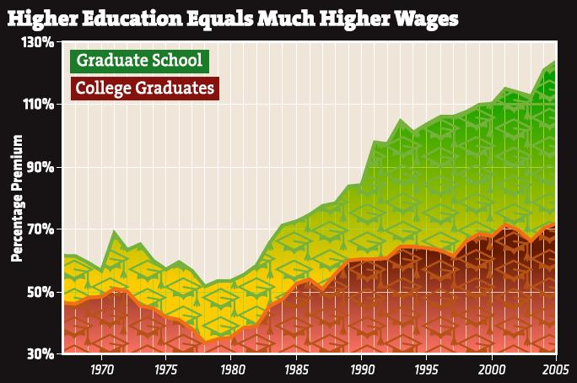
Percentage by which the wage of workers with college and graduate school educations exceeds that of workers with high school only.

To show the importance to inequality of
the increased return to human capital,
consider Figure 1, which shows the link
between earnings and education by
displaying the wage premium received by
college-educated workers compared with
high school graduates. In 1980, an
American with a college degree earned
about 30 percent more than an American
who stopped education at high school.
But, in recent years, a person with a college education earned roughly 70 percent more. Meanwhile, the premium for having a graduate degree increased from roughly 50 percent in 1980 to well over 100 percent today. The labor market is placing a greater emphasis on education, dispensing rapidly rising rewards to those who stay in school the longest.

This trend has contributed significantly to the growth in overall earnings inequality in the United States. And just as in China and India, this growing inequality gap is associated with growing oppor­tunity—in this case, the opportunity to advance through education. The upward trend in the returns to education is not limited to one segment of the population. Education premiums for women and African Americans have increased as much as, or more than, the premiums for all workers.

Figure 2 shows that the growth in returns to education for women has paralleled that for men over the past 25 years, but has remained at a somewhat higher level. Figure 3 shows that returns for blacks have increased as much as those for whites. As these two figures show, the potential to improve one’s labor-market prospects through higher education is greater now than at any time in the recent past, and this potential extends across gender and racial lines.

The growth in returns to college has generated a predictable response: as the education earnings gap increased, a larger fraction of high school graduates went on to college. As Figure 4 shows, the pro­portion of men and women ages 20 to 25 who attended college jumped by about half over the past 40 years, tracking the rise in the wage premium. When returns fell in the 1970s, the fraction going on to college declined. The rise in returns since 1980 has been accompanied by a significant rise in the fraction going on to college.[3]

This increase in the proportion of persons going on to higher education is found among all racial and ethnic groups, but it is particularly important for women, who, in 2004, outnumbered men as students in degree-granting institutions of higher education by 33 percent.

Women have also shifted toward higher-earn­ings fields, such as business, law, and medicine: the number of women in graduate schools rose 66 per­cent between 1994 and 2004, while the number of men rose just 25 percent.[4] And the greater education achievement of women compared to men is partic­ularly prominent among blacks and Latinos: the proportion of black women who attend colleges and universities jumped from 24 percent to 43 percent between 1974 and 2003, while the proportion of white men rose only from 41 percent to 49 percent.[5]

The potential generated by higher returns to education extends from individuals to the economy as a whole. Growth in the education level of the population has been a significant source of rising wages, productivity, and living standards over the past century. Higher returns to educa­tion will accelerate growth in living standards as existing investments have a higher return, and additional investments in education will be made in response to the higher returns. Gains from the higher returns will not be limited to GDP and other measures of economic activity; education provides a wide range of benefits not captured in GDP, and these will grow more rapidly as well due to the addi­tional investments in schooling.

Why is the earnings gap widening? Because the demand for educated and other skilled persons is growing. That is hardly surprising, given developments in computers and the Internet, advances in biotechnology, and a general shift in economic activity to more edu­cation-intensive sectors, such as finance and professional services. Also, globalization has encouraged the import­ing of products using relatively low-skilled labor from abroad. At the same time, world demand has risen for the kinds of products and services that are provided by high-skilled employees.

When calculating the returns to education, we look at the costs of education as well. And even accounting for the rise in university tuition (it more than doubled, on average, in constant dol­lars between 1980 and 2005), overall returns to college and graduate study have increased substan­tially. Indeed, it appears that the increases in tuition were partly induced by the greater return to col­lege education. Pablo Peña, in a Ph.D. dissertation in progress at the University of Chicago, argues con­vincingly that tuition rose in part because students want to invest more in the quality of their education, and increased spending per student by colleges is partly financed by higher tuition levels.[6] More invest­ment in the quality and quantity of schooling will benefit both individuals and society.

This brings us to our punch line. Should an increase in earnings inequality due primarily to higher rates of return on education and other skills be considered a favorable rather than an unfavor­able development? We think so. Higher rates of return on capital are a sign of greater productivity in the economy, and that inference is fully applica­ble to human capital as well as to physical capital. The initial impact of higher returns to human cap­ital is wider inequality in earnings (the same as the initial effect of higher returns on physical capital), but that impact becomes more muted and may be reversed over time as young men and women invest more in their human capital.
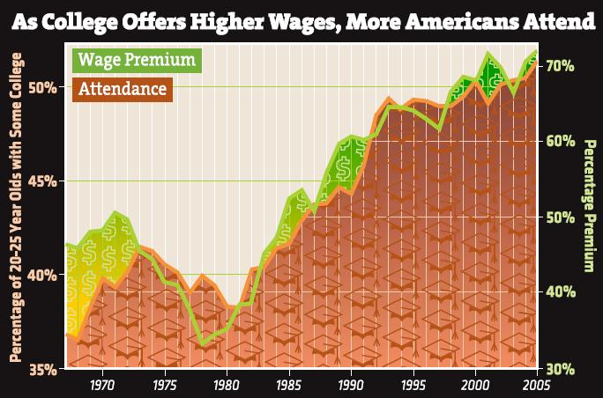

We conclude that the forces raising
earnings inequality in the United
States are beneficial to the extent
that they reflect higher returns to
investments in education and other
human capital. Yet this conclusion
should not produce complacency,
for the response so far to these
higher returns has been disturbingly
limited. For example, why haven’t
more high school graduates gone on
to a college education when the
benefits are so apparent? Why don’t
more of those who go to college finish a four-year degree? (Only about half do so.)[7] And why has the proportion of American youth who drop out of high school, especially African-American and Hispanic males, remained fairly constant?

The answers to these and related questions lie partly in the breakdown of the American family, and the resulting low skill levels acquired by many children in elementary and secondary school—particularly individuals from broken households. Cognitive skills tend to get developed at very early ages while, as our colleague James Heckman has shown, noncognitive skills—such as study hab­its, getting to appointments on time, and attitudes toward work—get fixed at later, although still rel­atively young, ages. Most high school dropouts certainly appear to be seriously deficient in the noncognitive skills that would enable them to take advantage of the higher rates of return to education and other human capital.

So instead of lamenting the increased earnings gap caused by education, policymakers and the pub­lic should focus attention on how to raise the fraction of American youth who complete high school and then go on for a college education. Solutions are not cheap or easy. But it will be a disaster if the focus remains so much on the earnings inequality itself that Congress tries to interfere directly with this inequality rather than trying to raise the education levels of those who are now being left behind.

For many, the solution to an increase in inequality is to make the tax structure more progressive—raise taxes on high-income households and reduce taxes on low-income households. While this may sound sensible, it is not. Would these same indi­viduals advocate a tax on going to college and a subsidy for dropping out of high school in response to the increased importance of education? We think not. Yet shifting the tax structure has exactly this effect.

A more sensible policy is to try to take greater advantage of the opportunities afforded by the higher returns to human cap­ital and encourage more human capital investment. Attempts to raise taxes and impose other penalties on the higher earnings that come from greater skills could greatly reduce the productivity of the world’s leading economy by dis­couraging investments in its most productive and precious form of capital—human capital.

Gary S. Becker, who won the Nobel Prize in Economics in 1992, teaches at the University of Chicago and is a senior fellow at the Hoover Institution at Stanford. His colleague at Chicago and Hoover, Kevin M. Murphy, was the 1997 winner of the John Bates Clark Medal of the American Economic Association, which goes to an outstanding economist under age forty

